
Summer Challenge – Year 5
How many things can you do over the holidays from our Summer Challenge?
We cannot wait to see what you got up to and hear all about it in September
English | Maths
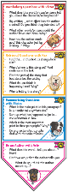  Reading comprehension  How many books can you read over the Summer? Perhaps you could complete the Summer Reading Challenge at the library. Use the bookmark in this pack to answer questions and talk about what you have read with an adult.  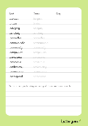  Spelling    Spelling is such an important factor to writing. In year five and six there is another set of curriculum words to know and use in your writing. You can learn these spellings while also practising your handwriting using the highlighted sheets.  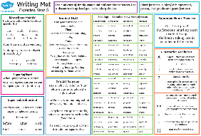  Grammar  Can you complete all of the grammar challenges over the holidays? Some involve brand new year five learning – use the year 5 writing mat to have a go and try to get ahead!  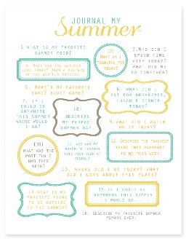  Writing stamina  In year five, you will have to write for a range of audiences and purposes. The expectations of the quality and quantity of your writing will be higher. Use the ten-minute writing tasks to practice getting a good amount of writing completed. Do not forget to check and edit your work at the end too! |   Times Tables  Times tables are so helpful in other aspects of year 5 maths. Make sure you know them all by working your way through the practice booklet.    Problem Solving  Real-life maths and the ability to solve problems is important. Get the bus into town and look at the bus timetable together. Pay with cash for something and count up totals and change. What about a 25% off sale? Do a spot of baking and look at measurements and conversions (litres – millilitres, kilograms – grams etc).    Written methods  We use formal written methods for addition, subtraction, multiplication and division in year 5. Practising these on paper and even on some websites like this one can help before more confident. https://www.transum.org/Software/  Arithmetic  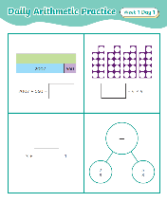  Artithmetic needs to be confident and fluent when moving into year 5. The daily arithmetic challenge booklet will keep key skills fresh ready to hit the ground running when you come back after the summer. Just 10 minutes a day (or slight longer once a week) is all you need to keep on top of this.

